Project Assignment: Classification

Introduction
The objective of this work is to predict churn. The dataset contains the details of a bank's customers and the target variable is a binary variable reflecting the fact whether the customer left the bank (closed his account) or he continues to be a customer. The focus of this report is about prediction: predicting if a client will churn or not will allow to take some actions to prevent churning.

The dataset
The dataset is composed of 13 features + 1 target variables:
- RowNumberRow: Numbers from 1 to 10000
- CustomerIdUnique: Ids for bank customer identification
- Surname: Customer's last name
- CreditScore: Credit score of the customer
- Geography: The country from which the customer belongs
- Gender: Male or Female
- Age: Age of the customer
- Tenure: Number of years for which the customer has been with the bank
- Balance: Bank balance of the customer
- NumOfProducts: Number of bank products the customer is utilising
- HasCrCard: Binary Flag for whether the customer holds a credit card with the bank or not
- IsActiveMember: Binary Flag for whether the customer is an active member with the bank or not
- EstimatedSalary: Estimated salary of the customer in Dollars
- Exited: Binary flag 1 if the customer closed account with bank and 0 if the customer is retained

Data preprocessing
A few features were dropped because they did not contain any useful data for prediction: RowNumberRow, CustomerIdUnique and SurnameCustomer’s
The feature “Estimated salary” was dropped as well, since it is not a real and reliable value, it is just an estimation. The are no missing values (the count for all features is 10000, which correspond to the size of the data set).
There were 2 categorical features: Geography and Gender, which were transformed in ordinal features using LabelEncoder.
From the seaborn pairplot, no clear correlation between features was observed (Figure 1).
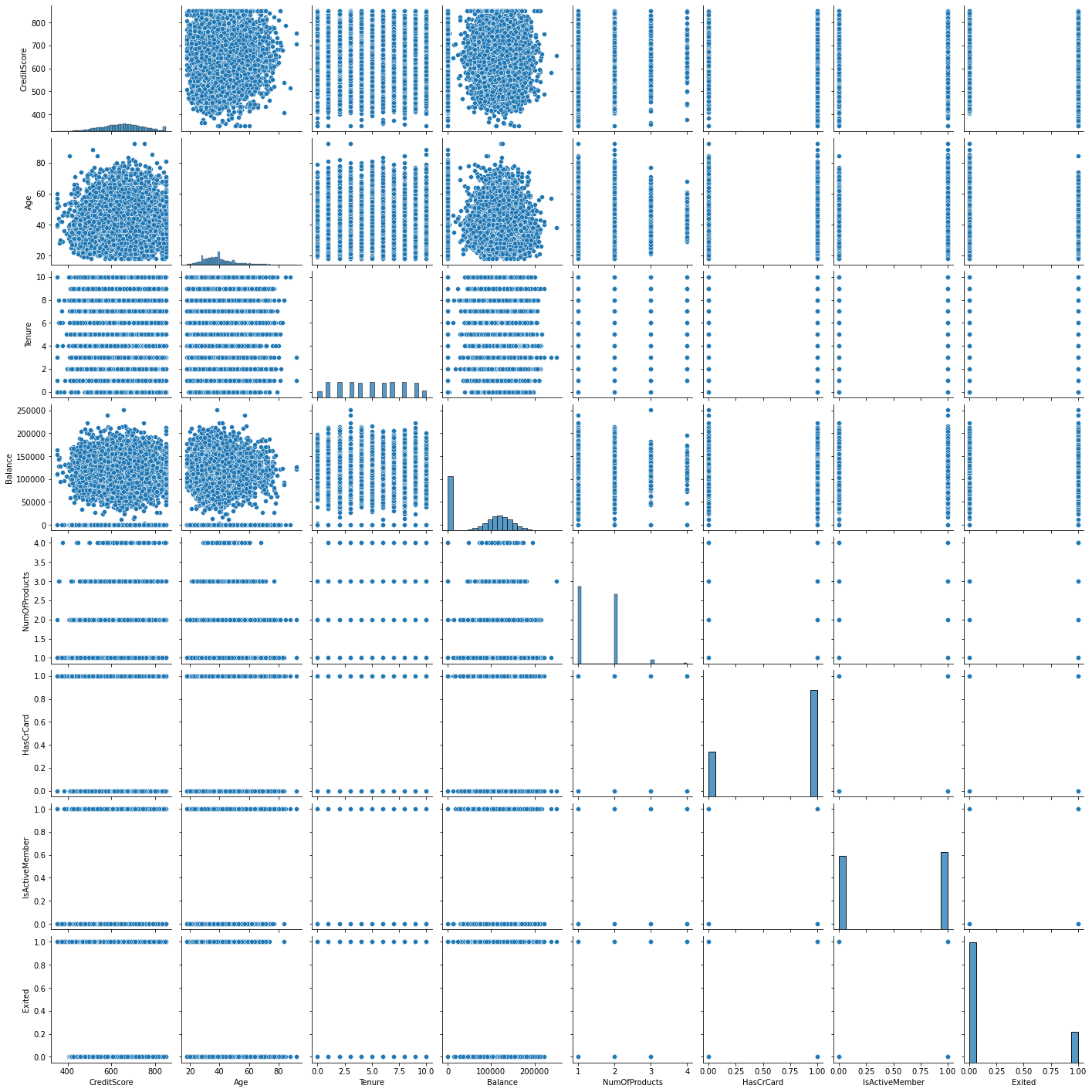
Figure 1: Seaborn pairplot
The target variable is not balanced: the count for not churning is 7963, for churn is 2037. To keep this distribution of the target variable, StratifiedShuffleSplit was used to split the data in training and test set.
Finally, since the features values are not on the same scale, StandardScaler was used to scale them.

Models

Experimental process
Several models were trained, including logistic regression with and without regularization, kNN (k-Nearest Neighboors), DecisionTreeClassifier and GradientBoostingClassifier. Except for the baseline logistic regression without regularization, GridSearch was used to optimize the classification with accuracy metric. The reported metric here is the accuracy, the reader can examine other metrics in the Annex. The same train and test set were used for all the models.

Results
- Logistic regression baseline (without regularization):
  - Accuracy score: 0.814
  - Most important features (from the coefficients): Age and Balance
- Logistic regressionCV withL2 regularization:
  - GridSearch explored the paramater Cs (iinverse of regularization strength):[0.1,0.5,1,10,50,100]. The best model was with Cs = 50
  - Accuracy : 0.81
  - Most important features (from the coefficients): Age and Balance
- kNN:
  - GridSearch explored the parameter n_neighbors:[1,3,5,10,20,40,50,100]} The best model was with n_neighbors = 10
  - Accuracy score: 0.85
- DecisionTreeClassifier:
  - GridSearch explored the parameters max_depth: range(1, dt.tree_.max_depth+1, 2),) and max_features: range(1, len(dt.feature_importances_)+1, where dt.tree_.max_depth and dt.feature_importances refer to the baseline DecisionTree without GridSearch. The best model was with max_depth=5, max_features=9
  - Accuracy score: 0.858
  - Most important features (from feature_importances_): Age and Number of Products
- GradientBoostingClassifier:
  - GridSearch explored the parameters n_estimators: [5.10,15, 25, 50, 100, 200, 400], max_features': [1, 2, 3, 4,6,7,8,9]} The best model was: n_estimators = 200, max_features = 9
  - Accuracy score: 0.872
  - Most important features (from feature_importances_): Age and Number of Products

DecisionTreeClassifier and GradientBoostingClassifier are pretty similar concerning metrics and feature importance. As the accuracy of GradientBoostingClassifier is slightly higher than DecisionTree, the recommendation is to use GradientBoostingClassifier to predict churn.

Summary, conclusions and perspectives
The best model is Gradient Boosting, with an accuracy of 0.872 on the test set. The model is not overfitting, since the accuracy on the test set is close of the accuracy on the train set, but the model could be biased and the accuracy could be optimized. Other relevant features could be added to examine their influence on the model: for example, professional category or an active loan in the bank (for example, when looking for a loan to buy a house, one person could decide to change bank to have lower interest rates. If someone already has an active loan with his bank, it may be that the probability of churning is lower).
For all models, age seems to be one of the most important features and driving factor. Another important feature, at least for the most accurate models - tree-based), is the number of products. This could be reasonable, since because of laziness or simplicity, if one detains a lot of products in the same bank, it could be more difficult to change bank and open a new contract for new products.
Since the age seems to be a driving factor, it would be interesting to examine more in detail the relationship between age and churn, to discover if some age-range is more prone to churn and design a retention marketing campaign adapted to that specific age range.
The models did not make a distinction between the different geographic locations (France, Spain and Germany). Since every country has its specificities, it could be interesting to train a model for each country to see if there is an effect on the accuracy.

Annexe

